|  |  |
| --- | --- |
|  | **FPT ACADEMY INTERNATIONAL**  **FPT – APTECH COMPUTER EDUCATION** |

**Centre Name: ACE-HCMC-2-FPT.**

**Address: 590 Cach Mang Thang 8, District 3, Ho Chi Minh City, Viet Nam.**

**KARNEL GUIDE TOUR PROJECT**

|  |  |  |
| --- | --- | --- |
| **Supervisor:** | Dinh Vu Quoc Trung | |
| **Semester:** | III | |
| **Batch No:** | Aptech Learning - ACCP i17-T11707E0 | |
| **Group No:** | 4 | |
| **Order:** | **Full name** | **Roll No.** |
| 1. | Ho Hoan Vu | Student1040381 |
| 2. | Vu Ngoc Truong | Student1040276 |
| 3. | Doan Khanh Nhi | Student1038300 |

Month **November** Year **2018**

# REVIEW 1

1. **Introduction**

* Karnel Travels is a Tours and Travels Company which provides the various transportation facilities between the cities like tourist spots, transportation between different cities in the country, also provides accommodations in hotels, etc. So, we will provide the online facility where the customers can visit online, view and search for the tours and as well the transportation.
* Now we will provide a website, through which they want to attract the customers. In website, we will provide various information services like the list of tourist spot, information about the various hotels and restaurants, etc.

1. **Customer Requirement Specification:**

We have two roles in this website and it will have special ability below:

* Customer will have ability:

+ Register, Login, Logout

+ View Home, Tourist Spots, Travel Information, Hotel Information, Restaurant Information, Resort Information, About us.

* Administrator will have ability:

+ Edit/Delete User

+ Add/Update/Delete Tour, Travel, Hotel, Restaurant, Resort

1. **Functional Requirements Specification**
2. **Customer:**

|  |  |  |  |
| --- | --- | --- | --- |
| **USE CASE SPECIFICATION** | | | |
| **Use-case No.** | UC001 | **Use-case Version** | 1.0 |
| **Use-case Name** | **Login** | | |
| **Actor:**  Admin, Customer  **Summary:**  login to application | | | |

|  |  |  |  |
| --- | --- | --- | --- |
| **USE CASE SPECIFICATION** | | | |
| **Use-case No.** | UC002 | **Use-case Version** | 1.0 |
| **Use-case Name** | **Log out** | | |
| **Actor:**  Admin, Customer  **Summary:**  Log out application  **Preconditions:**  Customer must login to the system | | | |

|  |  |  |  |
| --- | --- | --- | --- |
| **USE CASE SPECIFICATION** | | | |
| **Use-case No.** | UC003 | **Use-case Version** | 1.0 |
| **Use-case Name** | **Register Account** | | |
| **Actor:**  Customer  **Summary:**  Allow customer register new account  **Goal:**  Create new account  **Triggers**  **Preconditions:**  **Post Conditions:**  **Main Success Scenario:**  1. Customer enters information  2. Customer create new user  3. System determines the validity of the information  4. Add new information into the database  **Alternative Scenario:**  **Exceptions:**  **Relationships:**  **Business Rules:** | | | |

|  |  |  |  |
| --- | --- | --- | --- |
| **USE CASE SPECIFICATION** | | | |
| **Use-case No.** | UC004 | **Use-case Version** | 1.0 |
| **Use-case Name** | Update Customer profile | | |
| **Actor:**  Customer  **Summary:**  Allows customer to edit their account  **Goal:**  Edit Customer information  **Triggers**  **Preconditions:**  Customer must login to the system  **Post Conditions:**  Customer can update information  **Main Success Scenario:**  1. Customer login  2. Customer select his profile  3. Edit information that he wants to change  4. System determines the validity of the information  5. Update into the database  **Alternative Scenario:**  **Exceptions:**  **Relationships:** Update account  **Business Rules:** | | | |

|  |  |  |  |
| --- | --- | --- | --- |
| **USE CASE SPECIFICATION** | | | |
| **Use-case No.** | UC005 | **Use-case Version** | 1.0 |
| **Use-case Name** | Search Tourist Spots | | |
| **Actor:**  Customer  **Summary:**  Allows customer to search Tourist Spots  **Goal:**  Show Tourist Spots information  **Triggers**  **Preconditions:**  **Post Conditions:**  Tourist Spots information  **Main Success Scenario:**  1. Customer choose Search Page  2. Customer choose Tourist Spots search Type  3. System determines the validity of search key words  4. Show all information about Tourist Spots. | | | |

|  |  |  |  |
| --- | --- | --- | --- |
| **USE CASE SPECIFICATION** | | | |
| **Use-case No.** | UC006 | **Use-case Version** | 1.0 |
| **Use-case Name** | Search Hotel Information | | |
| **Actor:**  Customer  **Summary:**  Allows customer to search Hotel Information  **Goal:**  Show Hotel Information  **Triggers**  **Preconditions:**  **Post Conditions:**  Hotel Information  **Main Success Scenario:**  1. Customer choose Search Page  2. Customer choose Hotel Information search Type  3. System determines the validity of search key words  4. Show all information about Hotel Information. | | | |

|  |  |  |  |
| --- | --- | --- | --- |
| **USE CASE SPECIFICATION** | | | |
| **Use-case No.** | UC007 | **Use-case Version** | 1.0 |
| **Use-case Name** | Search Restaurant Information | | |
| **Actor:**  Customer  **Summary:**  Allows customer to search Restaurant Information  **Goal:**  Show Restaurant Information  **Triggers**  **Preconditions:**  **Post Conditions:** Restaurant Information  **Main Success Scenario:**  1. Customer choose Search Page  2. Customer choose Restaurant Information search Type  3. System determines the validity of search key words  4. Show all information about Restaurant Information. | | | |

|  |  |  |  |
| --- | --- | --- | --- |
| **USE CASE SPECIFICATION** | | | |
| **Use-case No.** | UC008 | **Use-case Version** | 1.0 |
| **Use-case Name** | Search Travel Information | | |
| **Actor:**  Customer  **Summary:**  Allows customer to search Travel Information  **Goal:**  Show Travel Information  **Triggers**  **Preconditions:**  **Post Conditions:** Travel Information  **Main Success Scenario:**  1. Customer choose Search Page  2. Customer choose Travel Information search Type  3. System determines the validity of search key words  4. Show all information about Travel Information. | | | |

|  |  |  |  |
| --- | --- | --- | --- |
| **USE CASE SPECIFICATION** | | | |
| **Use-case No.** | UC009 | **Use-case Version** | 1.0 |
| **Use-case Name** | Search Resort Information | | |
| **Actor:**  Customer  **Summary:**  Allows customer to search Resort Information  **Goal:**  Show Resort Information  **Triggers**  **Preconditions:**  **Post Conditions:**  Resort Information  **Main Success Scenario:**  1. Customer choose Search Page  2. Customer choose Resort Information search Type  3. System determines the validity of search key words  4. Show all information about Travel Information. | | | |

|  |  |  |  |
| --- | --- | --- | --- |
| **USE CASE SPECIFICATION** | | | |
| **Use-case No.** | UC010 | **Use-case Version** | 1.0 |
| **Use-case Name** | Order Tour | | |
| **Actor:**  Customer  **Summary:**  Allows customer to order Tour  **Goal:**  Order Tour with Tourist Spots, Restaurant, Resort, Hotel  **Triggers**  **Preconditions:**  **Post Conditions:**  **Main Success Scenario:**  1. Customer choose Tour  2. Customer click button Add Tour  3. System add Tour into Cart  4. Show all order information. | | | |

1. **Administrator:**

|  |  |  |  |
| --- | --- | --- | --- |
| **USE CASE SPECIFICATION** | | | |
| **Use-case No.** | UC011 | **Use-case Version** | 1.0 |
| **Use-case Name** | Add Hotel/Resort/Travel/Tourist Spots/Restaurant Information | | |
| **Actor:**  Administrator  **Summary:**  Allows Administrator to add Hotel/Resort/Travel/Tourist Spots/Restaurant Information  **Goal:**  Add Hotel/Resort/Travel/Tourist Spots/Restaurant Information  **Triggers**  **Preconditions:**  Administrator must login to the system  **Post Conditions:**  Administrator can update information  **Main Success Scenario:**  1. Administrator login  2. Administrator choose Hotel/Resort/Travel/Tourist Spots/  Restaurant Information.  3. Add new information that he wants  4. System determines the validity of the information  5. Create new information into the database  **Alternative Scenario:**  **Exceptions:**  **Relationships:** Update Hotel/Resort/Travel/Tourist Spots/Restaurant  **Business Rules:** | | | |

|  |  |  |  |
| --- | --- | --- | --- |
| **USE CASE SPECIFICATION** | | | |
| **Use-case No.** | UC012 | **Use-case Version** | 1.0 |
| **Use-case Name** | Edit Hotel/Resort/Travel/Tourist Spots/Restaurant Information | | |
| **Actor:**  Administrator  **Summary:**  Allows Administrator to edit Hotel/Resort/Travel/Tourist Spots/Restaurant Information  **Goal:**  Edit Hotel/Resort/Travel/Tourist Spots/Restaurant Information  **Triggers**  **Preconditions:**  Administrator must login to the system  **Post Conditions:**  Administrator can update information  **Main Success Scenario:**  1. Administrator login  2. Administrator choose Hotel/Resort/Travel/Tourist Spots/  Restaurant Information.  3. Edit information that he wants to change  4. System determines the validity of the information  5. Update into the database  **Alternative Scenario:**  **Exceptions:**  **Relationships:** Update Hotel/Resort/Travel/Tourist Spots/Restaurant  **Business Rules:** | | | |

|  |  |  |  |
| --- | --- | --- | --- |
| **USE CASE SPECIFICATION** | | | |
| **Use-case No.** | UC013 | **Use-case Version** | 1.0 |
| **Use-case Name** | Delete Hotel/Resort/Travel/  Tourist Spots/Restaurant Information | | |
| **Actor:**  Administrator  **Summary:**  Allows Administrator to delete Hotel/Resort/Travel/Tourist Spots/Restaurant Information  **Goal:**  Delete Hotel/Resort/Travel/Tourist Spots/Restaurant Information  **Triggers**  **Preconditions:**  Administrator must login to the system  **Post Conditions:**  Administrator can update information  **Main Success Scenario:**  1. Administrator login  2. Administrator choose Hotel/Resort/Travel/Tourist Spots/  Restaurant Information.  3. Delete information that he wants  4. System determines the validity of the information  5. Update flag to check that record is deleted in database  **Alternative Scenario:**  **Exceptions:**  **Relationships:** Update Hotel/Resort/Travel/Tourist Spots/Restaurant  **Business Rules:** | | | |

|  |  |  |  |
| --- | --- | --- | --- |
| **USE CASE SPECIFICATION** | | | |
| **Use-case No.** | UC014 | **Use-case Version** | 1.0 |
| **Use-case Name** | Edit Customer Information | | |
| **Actor:**  Administrator  **Summary:**  Allows Administrator to edit Customer Information  **Goal:**  Edit Customer Information  **Triggers**  **Preconditions:**  Administrator must login to the system  **Post Conditions:**  Administrator can update information  **Main Success Scenario:**  1. Administrator login  2. Administrator choose Customer Information.  3. Edit information that he wants to change  4. System determines the validity of the information  5. Update into the database  **Alternative Scenario:**  **Exceptions:**  **Relationships:** Update Hotel/Resort/Travel/Tourist Spots/Restaurant  **Business Rules:** | | | |

|  |  |  |  |
| --- | --- | --- | --- |
| **USE CASE SPECIFICATION** | | | |
| **Use-case No.** | UC015 | **Use-case Version** | 1.0 |
| **Use-case Name** | Delete Customer Information | | |
| **Actor:**  Administrator  **Summary:**  Allows Administrator to delete Customer Information  **Goal:**  Delete Customer Information  **Triggers**  **Preconditions:**  Administrator must login to the system  **Post Conditions:**  Administrator can update information  **Main Success Scenario:**  1. Administrator login  2. Administrator choose Customer Information.  3. Delete information that he wants  4. System determines the validity of the information  5. Update flag to check that record is deleted in database  **Alternative Scenario:**  **Exceptions:**  **Relationships:** Update Hotel/Resort/Travel/Tourist Spots/Restaurant  **Business Rules:** | | | |

1. **System Requirement**
2. **Hardware Requirement**

* Pentium IV 1.4 Ghz or higher
* RAM: 512 MB or better
* HDD: 200MB or higher

1. **Software Requirement**

**Sever:**

* Windows 7 or higher (Recommended)
* IE 6.0 or higher, Mozilla Firefox 3.0, Google Chrome 66.0
* IIS (Internet Information Services)
* SQL Server 2012

**Client:**

* Windows Xp or higher (Recommended),
* Chrome.

**Task Sheet Review 1**

|  |  |  |  |  |  |
| --- | --- | --- | --- | --- | --- |
| **Members Group** | | **Date Preparation of Activity Plan** | | | |
| **No** | **Name** | **Description Task** | **Start Date** | **End Date** | **Status** |
| 1 | Hồ Hoàn Vũ | Functional Requirement (Customer) | **Oct 5,2018** | **Oct 9,2018** | Completed |
| 2 | Vũ Ngọc Trường | Functional Requirement (Administrator) | **Oct 5,2018** | **Oct 9,2018** | Completed |
| 3 | Đoàn Khánh Nhi | Introduction, Customer Requirement | **Oct 5,2018** | **Oct 9,2018** | Completed |
|  | | | | | |
| **Teacher** | | | **Team Leader** | | |
|  | | |  | | |
| **Dinh Vu Quoc Trung** | | | **Hồ Hoàn Vũ** | | |

# REVIEW 2

1. **Architecture & Design of the Project:**
2. **Architectural pattern**

use MVC:

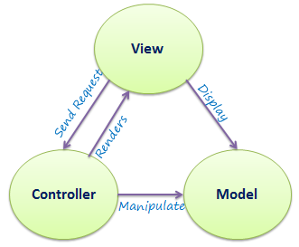

1. **Design Project:**

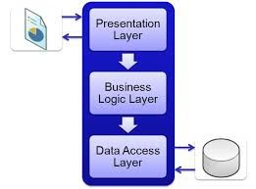

**Presentation Tier:**

Use technologies: HTML, JavaScript, jQuery, Bootstrap, CSS, Ajax.

Controller: Use ASP.NET MVC

**Business Logic Tier:**

Use technologies: ASP.NET

**Data Access Tier:** SQL Server, ADO.NET

1. **Use Case:**

Admin

Karnel Guide System





1. **Administrator Use Case:**

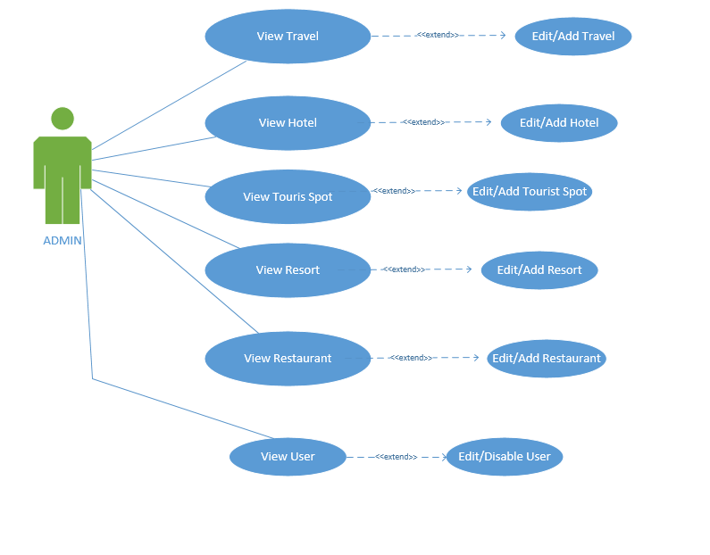

1. 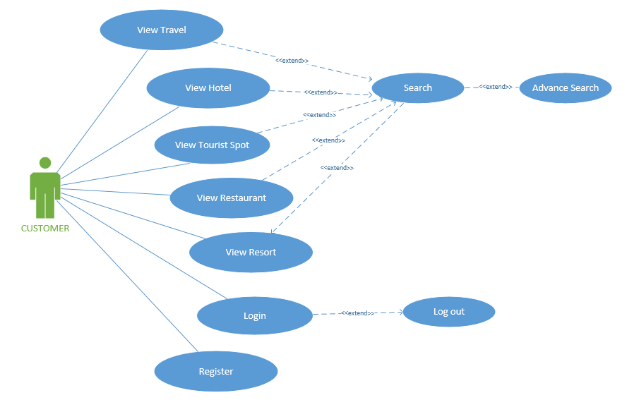**Customer User Cages:**
2. **Functional Main Flow**
3. **Admin**
4. **Login (Admin + Customer)**

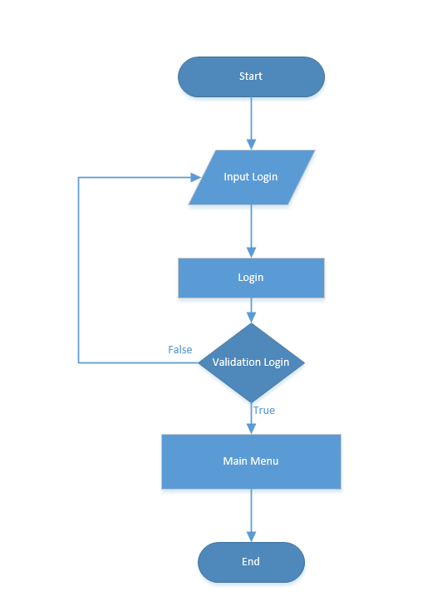

1. **Logout Admin**

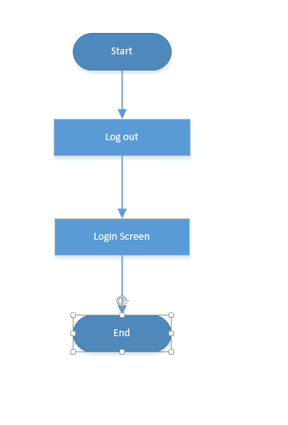

1. **Search Travel/Hotel/Resort/Tourist Spot/Restaurant (Admin)**

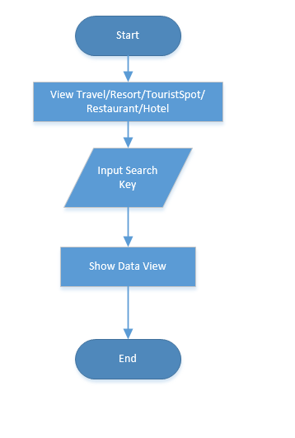

1. **Search User (Admin)**

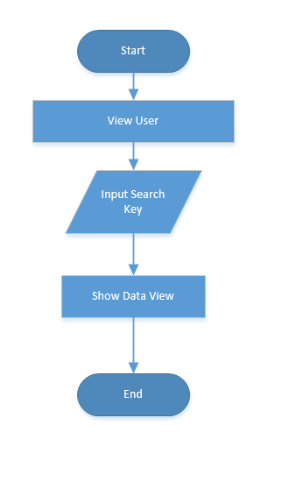

1. **Add new Hotel/Resort/Restaurant/Tourist Spot/Travel (Admin)**

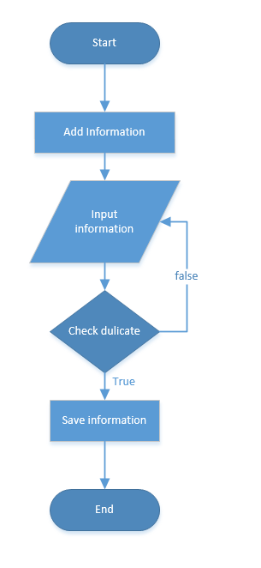

1. **Edit Hotel/Resort/Restaurant/Tourist Spot/Travel (Admin)**

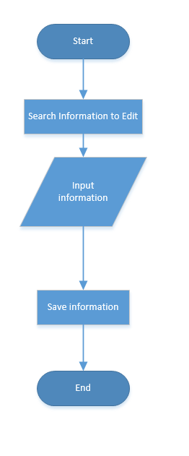

1. **Disable user (Admin)**

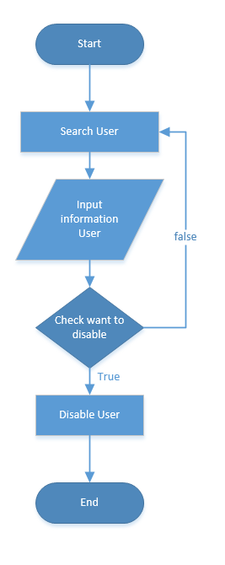

1. **Customer**
2. **View Hotel/Travel/Resort/Restaurant/Tourist Spot/Travel**

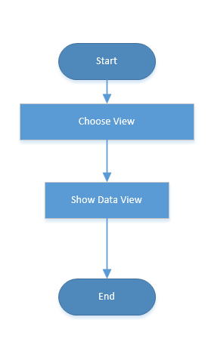

1. **Search Information (Hotel/Travel/Resort/Restaurant/Tourist Spot/Travel)**

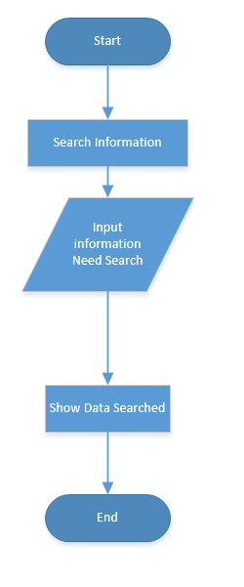

1. **Advance Search Information (Hotel/Travel/Resort/Restaurant/Tourist Spot/Travel)**

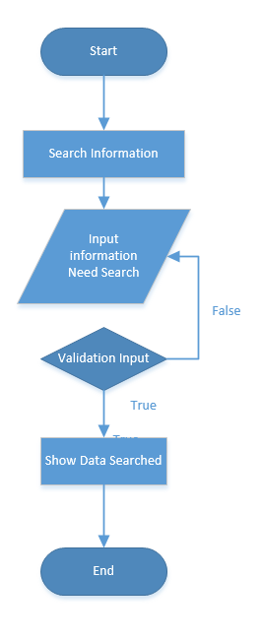

1. **Sequence Diagram**
2. **Administrator**
3. **Add/Edit/Delete:**

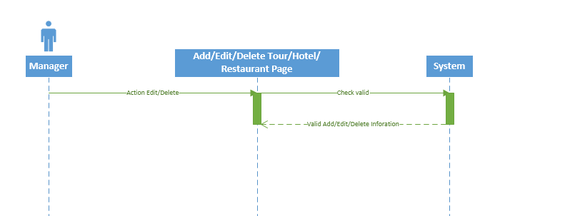

1. **Edit/Delete User:**

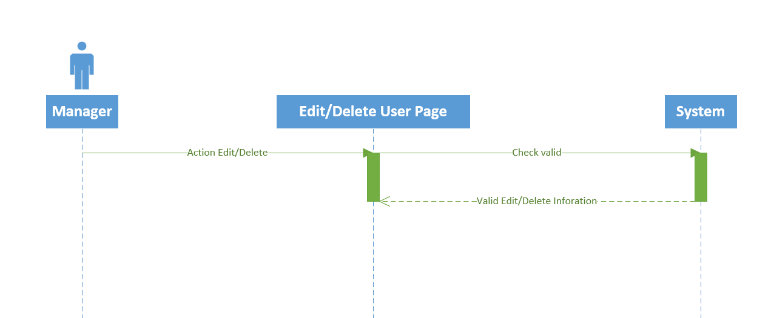

1. **Customer**
2. 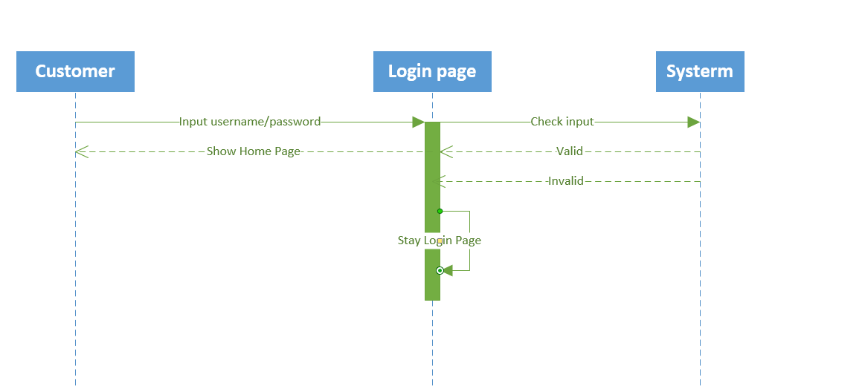**Login**
3. 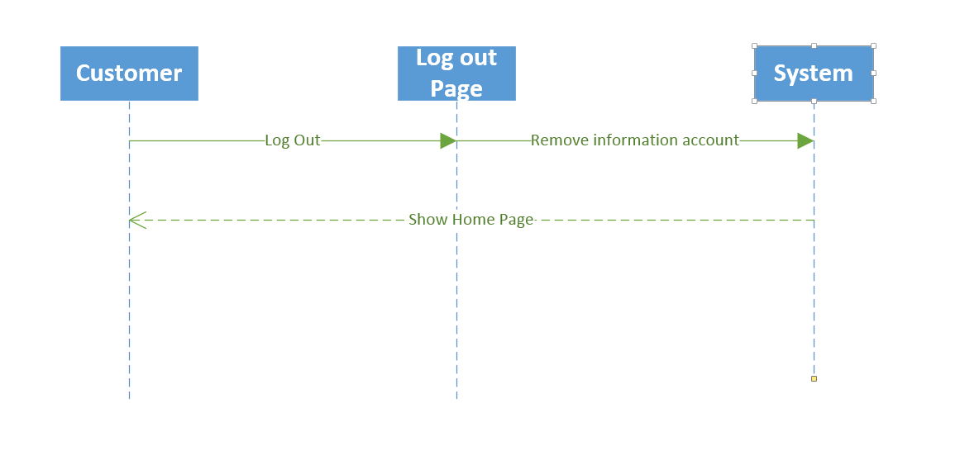**Logout**
4. **Register**

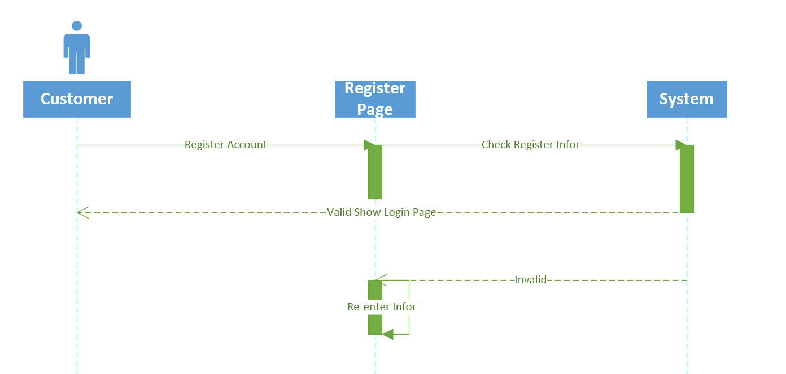

1. 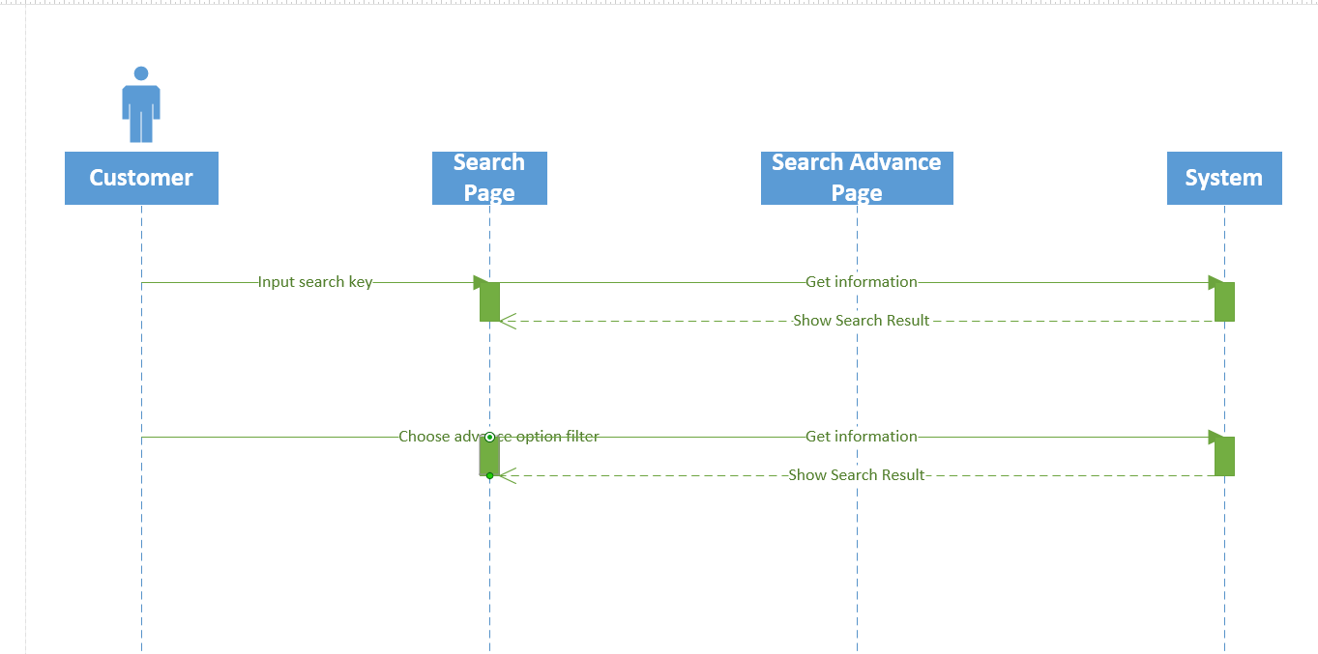**Search**
2. 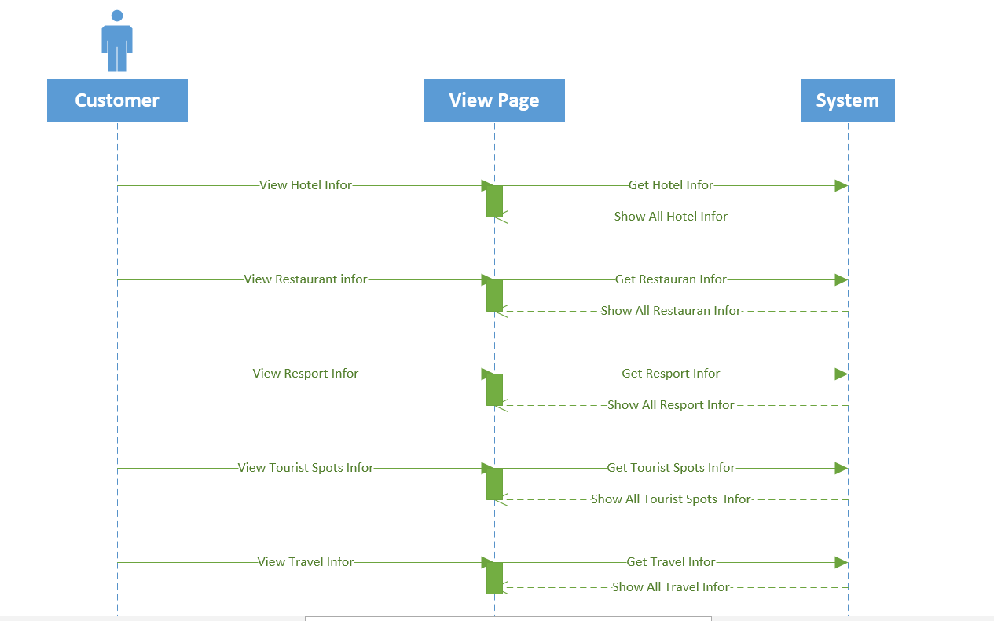**View**
3. **Website map**
4. 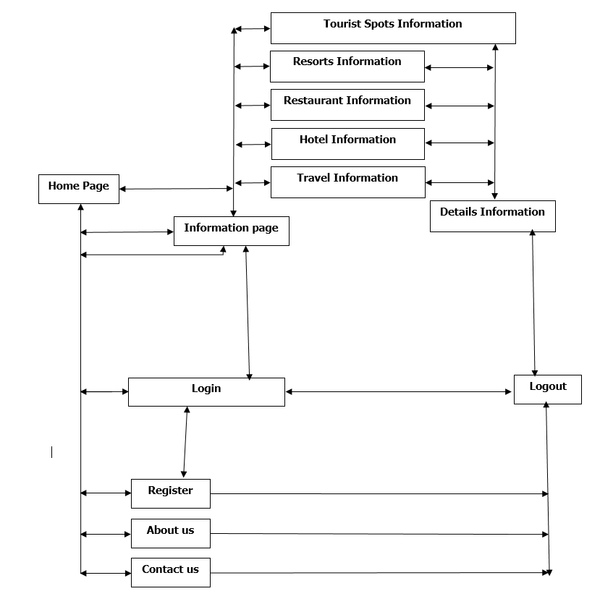**Customer Guide**

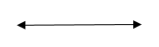**Note: From Page to Page**

1. **Administrator Guide:**

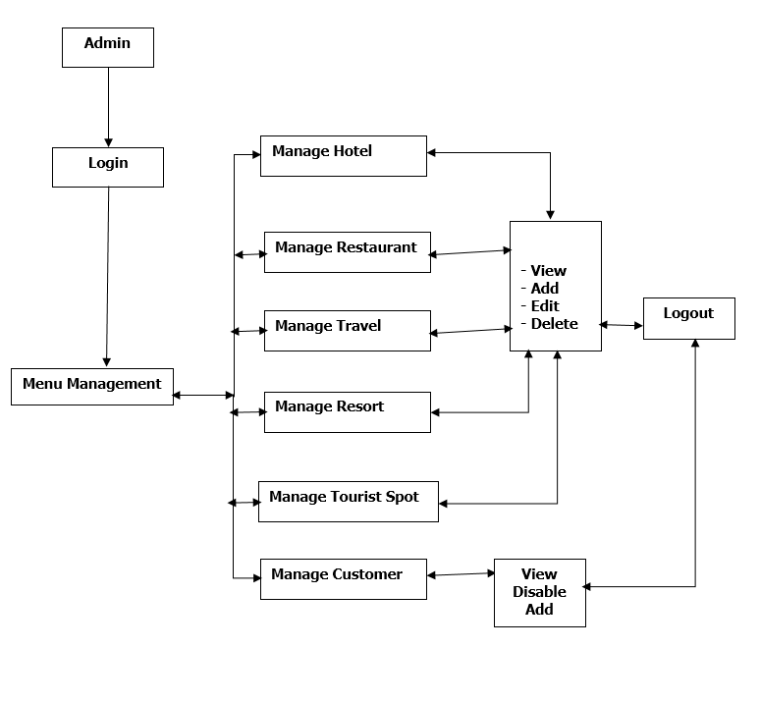

**Note: From Page to Page**

1. **Entity Relation Diagram:**

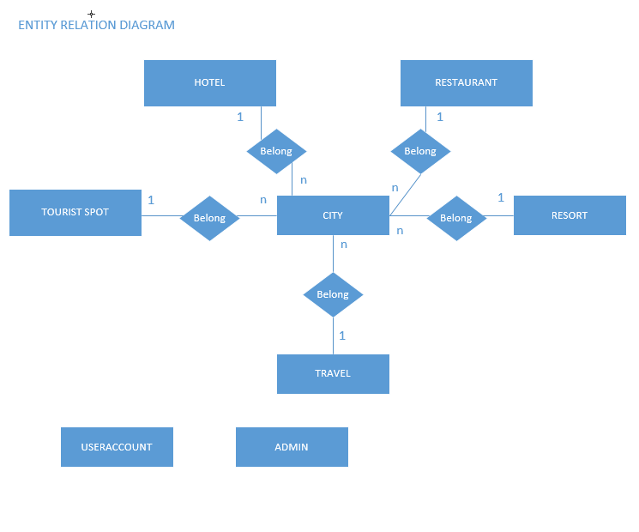

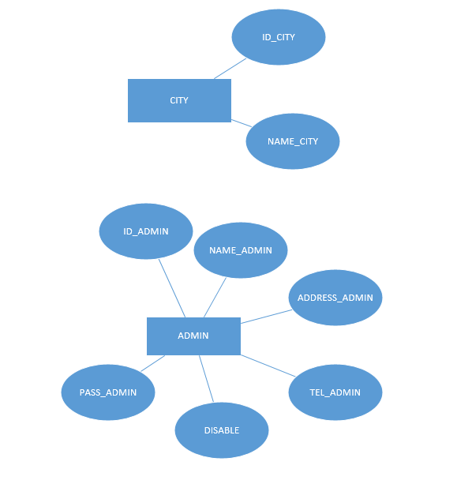

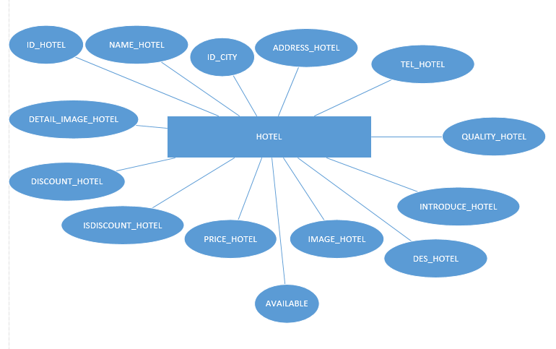

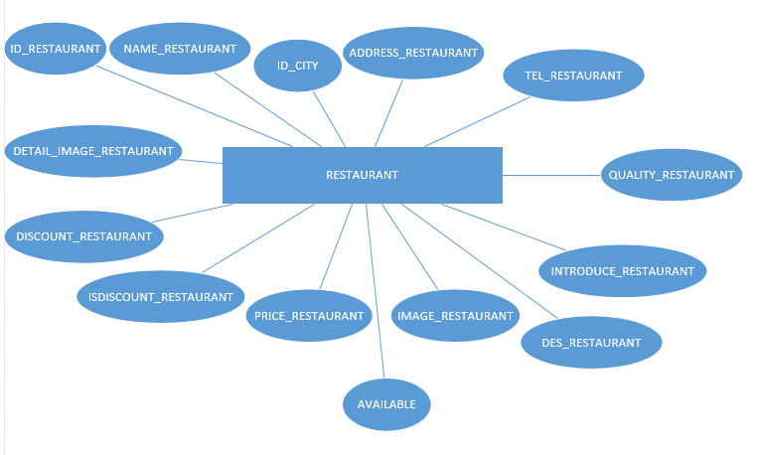

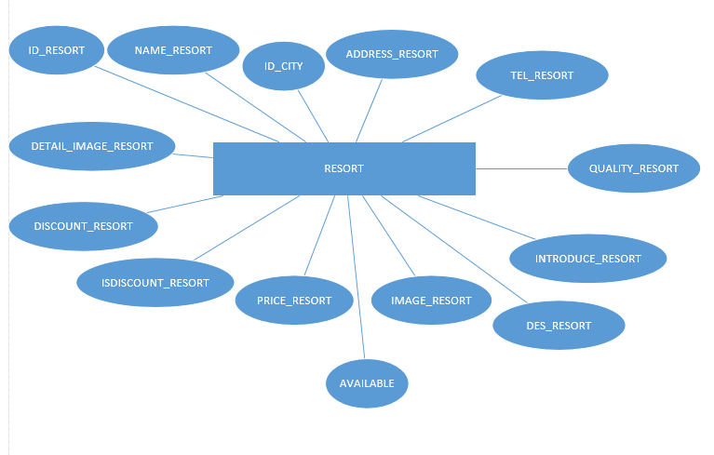

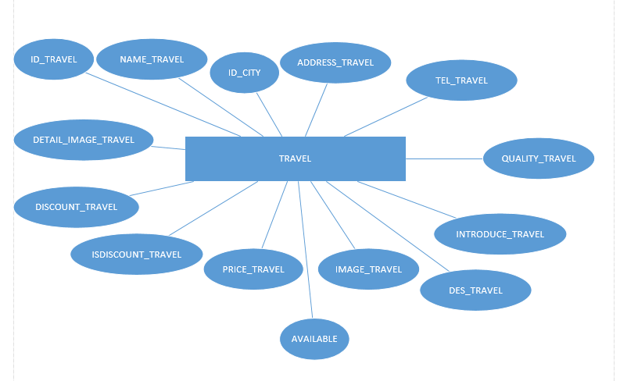

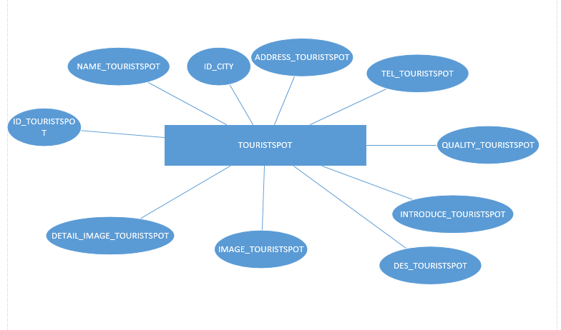

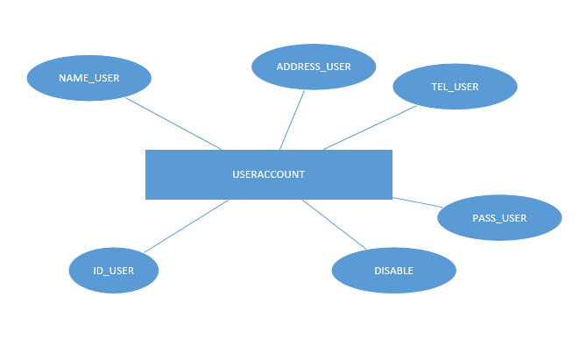

1. **Data flow**

**Admin**

**Admin**

**Restaurant**

**Admin**

**Tourist Spots**

**Admin**

**Resort**

**Admin**

**Hotel**

**Admin**

**Travel**

**Admin**

**User**

**Task Sheet Review 2**

|  |  |  |  |  |  |
| --- | --- | --- | --- | --- | --- |
| **Members Group** | | **Date Preparation of Activity Plan** | | | |
| **No** | **Name** | **Description Task** | **Start Date** | **End Date** | **Status** |
| 1 | Hồ Hoàn Vũ | Architecture & Design  Sequence Diagram  Use Case  ERD | **Oct 8,2018** | **Oct 11,2018** | Completed |
| 2 | Vũ Ngọc Trường | Data flow  Functional Flow | **Oct 8,2018** | **Oct 112018** | Completed |
| 3 | Đoàn Khánh Nhi | Use Case  Site Map  ERD | **Oct 8,2018** | **Oct 11,2018** | Completed |
|  | | | | | |
| **Teacher** | | | **Team Leader** | | |
|  | | |  | | |
| **Dinh Vu Quoc Trung** | | | **Hồ Hoàn Vũ** | | |

## 

**REVIEW 3**

**I. ERD Diagram:**

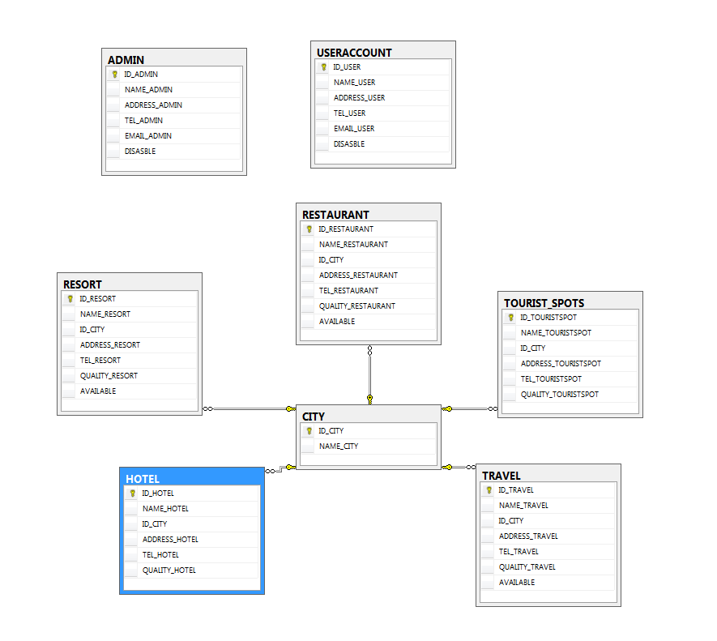

|  |  |  |  |  |
| --- | --- | --- | --- | --- |
| **Hotel Table** | | | | |
| **Column Name** | **Data Type** | **Length** | **Allow Nulls** | **Description** |
| ID_HOTEL | int, (PK) |  | 🞎 | ID Hotel |
| NAME_HOTEL | varchar | 200 | 🞎 | Name of Hotel |
| ID_CITY | varchar | 3 | 🞎 | ID City |
| TEL_HOTEL | varchar | 10 | 🞎 | Tel of hotel |
| ADDRESS_HOTEL | varchar | 200 |  | Address hotel |
| QUALITY_HOTEL | int |  | 🞎 | Quality of hotel |

|  |  |  |  |  |
| --- | --- | --- | --- | --- |
| **Restaurant Table** | | | | |
| **Column Name** | **Data Type** | **Length** | **Allow Nulls** | **Description** |
| ID_RESTAURANT | int, (PK) |  | 🞎 | ID Restaurant |
| NAME_RESTAURANT | varchar | 200 | 🞎 | Name of Restaurant |
| ID_CITY | varchar | 3 | 🞎 | ID City |
| TEL_RESTAURANT | varchar | 10 | 🞎 | Tel of Restaurant |
| ADDRESS_RESTAURANT | varchar | 200 |  | Address Restaurant |
| QUALITY_RESTAURANT | int |  | 🞎 | Quality of Restaurant |

|  |  |  |  |  |
| --- | --- | --- | --- | --- |
| **Resort Table** | | | | |
| **Column Name** | **Data Type** | **Length** | **Allow Nulls** | **Description** |
| ID_RESORT | int, (PK) |  | 🞎 | ID Resort |
| NAME_RESORT | varchar | 200 | 🞎 | Name of Resort |
| ID_CITY | varchar | 3 | 🞎 | ID City |
| TEL_RESORT | varchar | 10 | 🞎 | Tel of Resort |
| ADDRESS_RESORT | varchar | 200 |  | Address Resort |
| QUALITY_RESORT | int |  | 🞎 | Quality of Resort |

|  |  |  |  |  |
| --- | --- | --- | --- | --- |
| **Travel Table** | | | | |
| **Column Name** | **Data Type** | **Length** | **Allow Nulls** | **Description** |
| ID_TRAVEL | int, (PK) |  | 🞎 | ID Travel |
| NAME_TRAVEL | varchar | 200 | 🞎 | Name of Travel |
| ID_CITY | varchar | 3 | 🞎 | ID City |
| TEL_TRAVEL | varchar | 10 | 🞎 | Tel of Travel |
| ADDRESS_TRAVEL | varchar | 200 |  | Address Travel |
| QUALITY_TRAVEL | int |  | 🞎 | Quality of Travel |

|  |  |  |  |  |
| --- | --- | --- | --- | --- |
| **TOURIST_SPOTS Table** | | | | |
| **Column Name** | **Data Type** | **Length** | **Allow Nulls** | **Description** |
| ID_TOURISTSPOTS | int, (PK) |  | 🞎 | ID TOURIST_SPOTS |
| NAME_TOURISTSPOTS | varchar | 200 | 🞎 | Name of TOURIST_SPOTS |
| ID_CITY | varchar | 3 | 🞎 | ID City |
| TEL_TOURISTSPOTS | varchar | 10 | 🞎 | Tel of TOURIST_SPOTS |
| ADDRESS_TOURISTSPOTS | varchar | 200 |  | Address TOURIST_SPOTS |
| QUALITY_TOURISTSPOTS | int |  | 🞎 | Quality of TOURIST_SPOTS |

|  |  |  |  |  |
| --- | --- | --- | --- | --- |
| **CITY Table** | | | | |
| **Column Name** | **Data Type** | **Length** | **Allow Nulls** | **Description** |
| ID_TOURISTSPOTS | int, (PK) |  | 🞎 | ID CITY |
| NAME_TOURISTSPOTS | varchar | 200 | 🞎 | Name of CITY |

**II. Website**

1. **Home page**

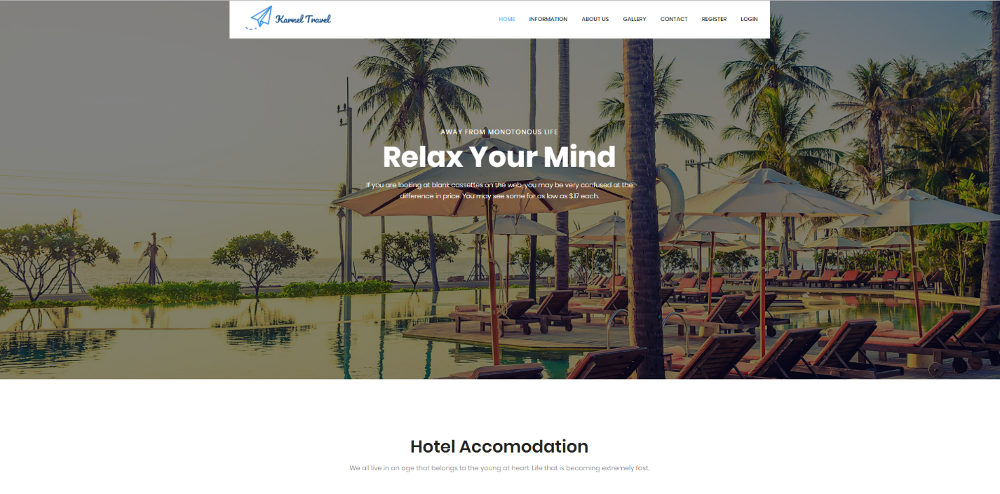

1. **Main menu**



1. 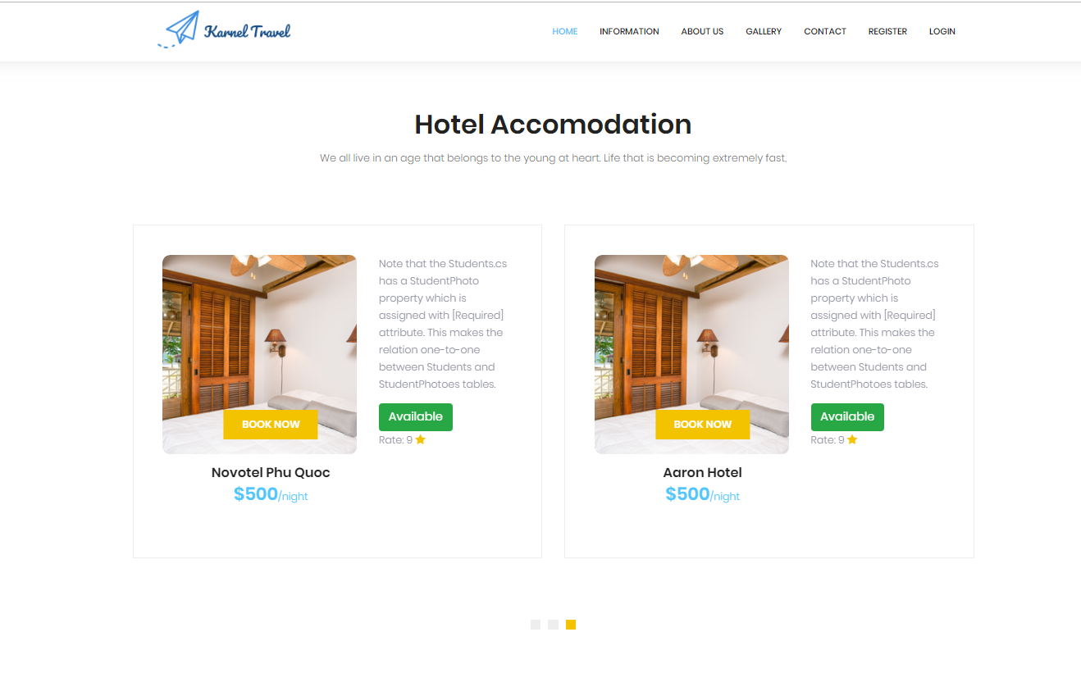**Home Page Detail**
2. **Register Form:**

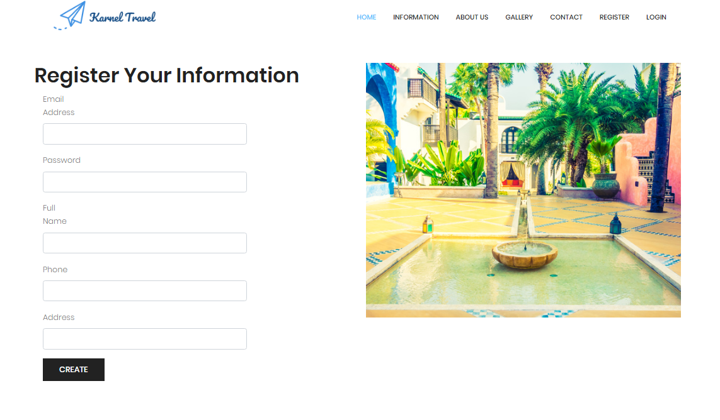

|  |  |
| --- | --- |
| Field | Validation |
| Email Address | Check existing email, check format e-mail, Check space |
| Password | Check space |
| Phone | Check type is phone, Check space |

1. **Login Page**

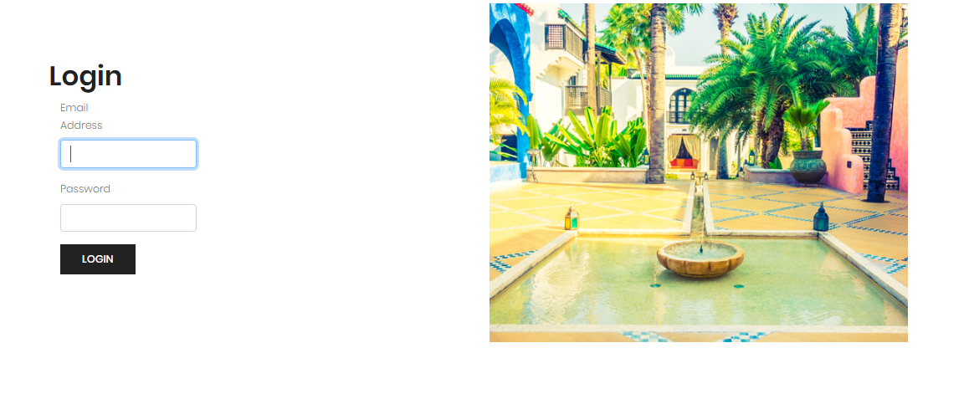

|  |  |
| --- | --- |
| Field | Validation |
| Email Address | Check existing email, check format e-mail, Check space |
| Password | Check space |

1. **Show Information Menu**

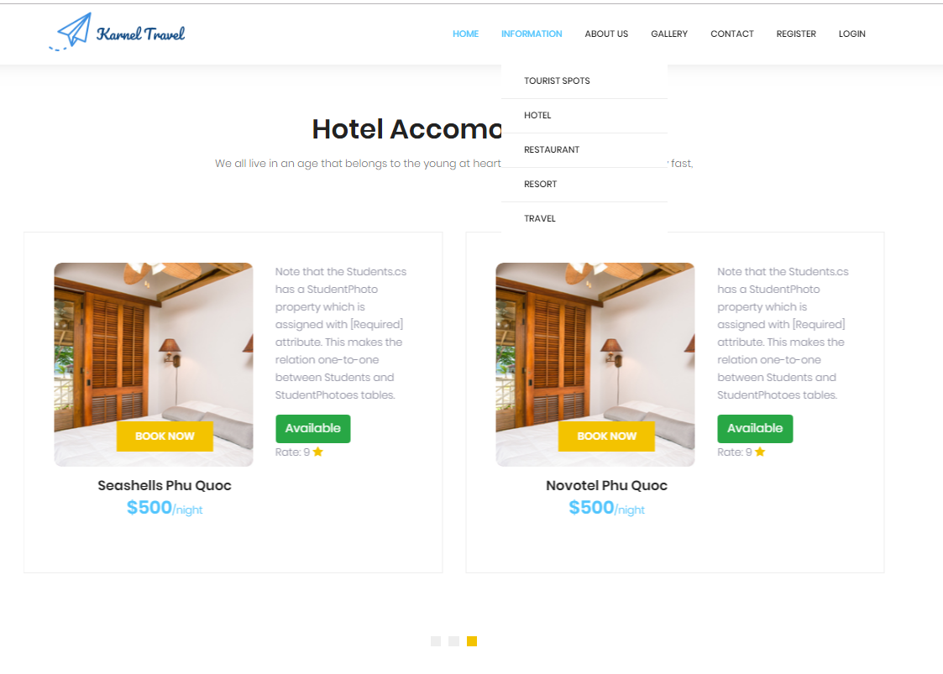

1. **Tourist Spot Information**

## 

## Detail Tourist Spot

## K. Hotel Information

## 

## L. Detail Hotel Information

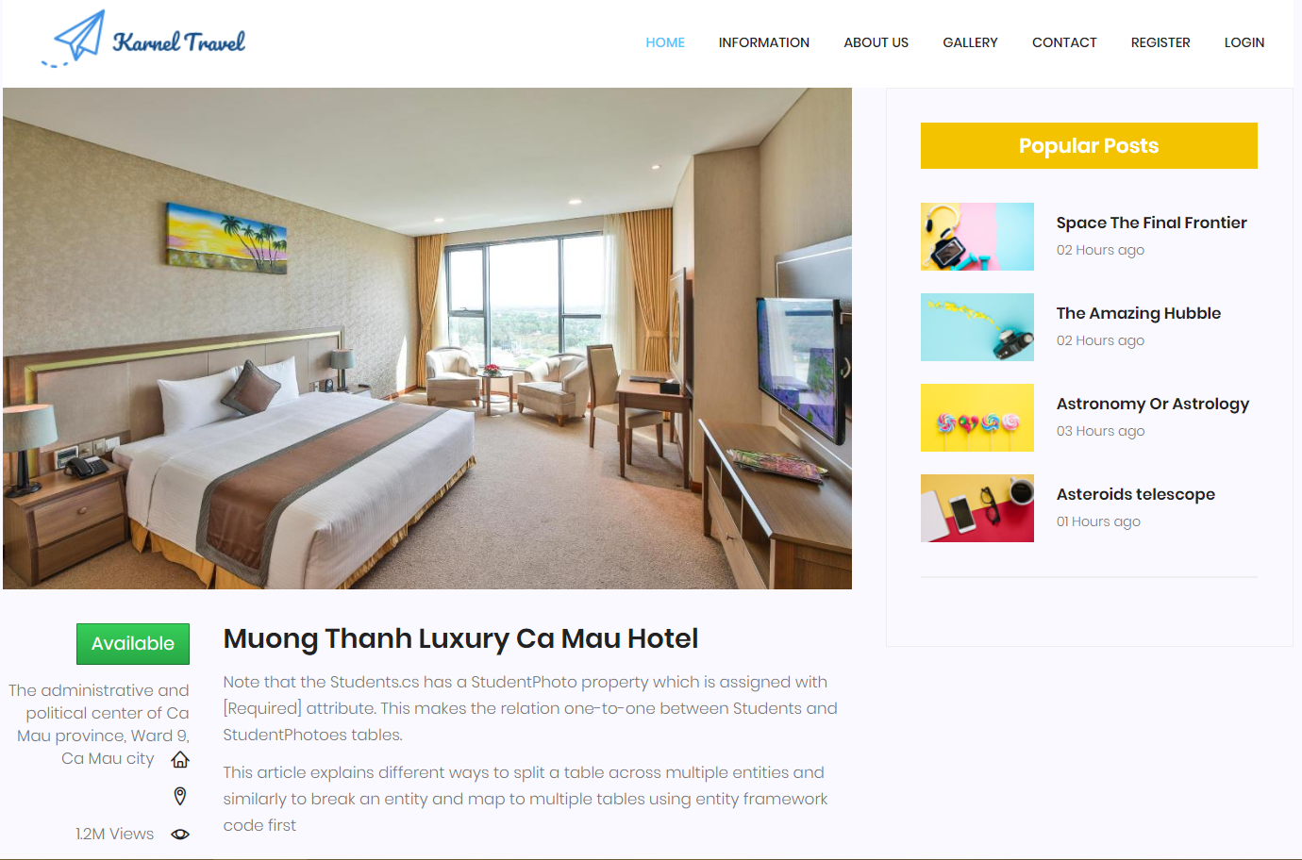

## M. Resort Information

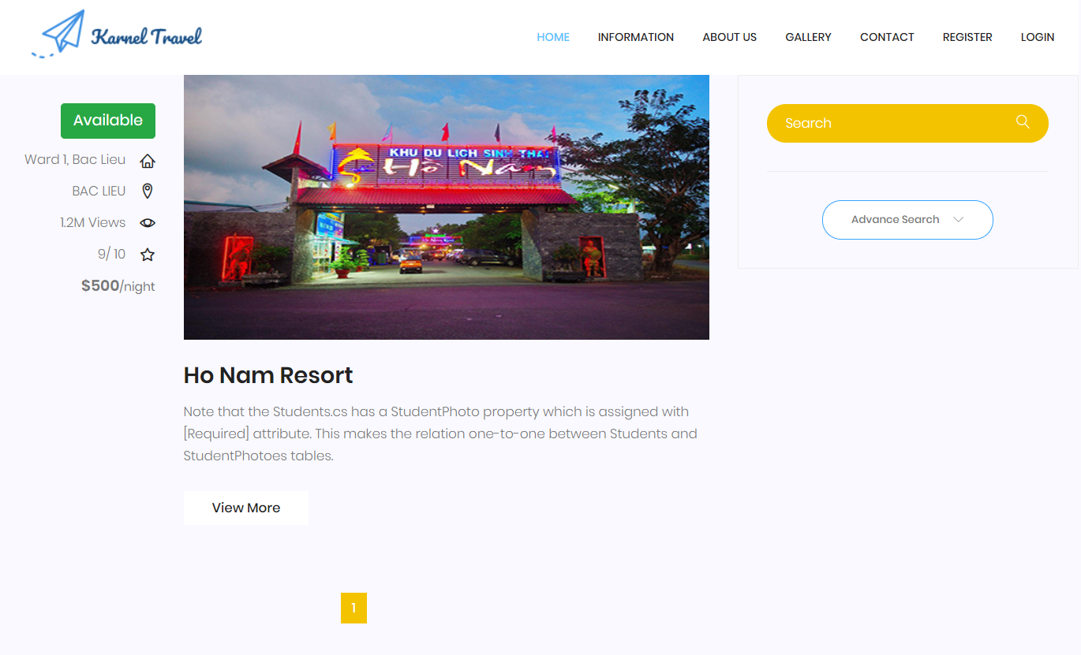

**N. Detail Resort Information**

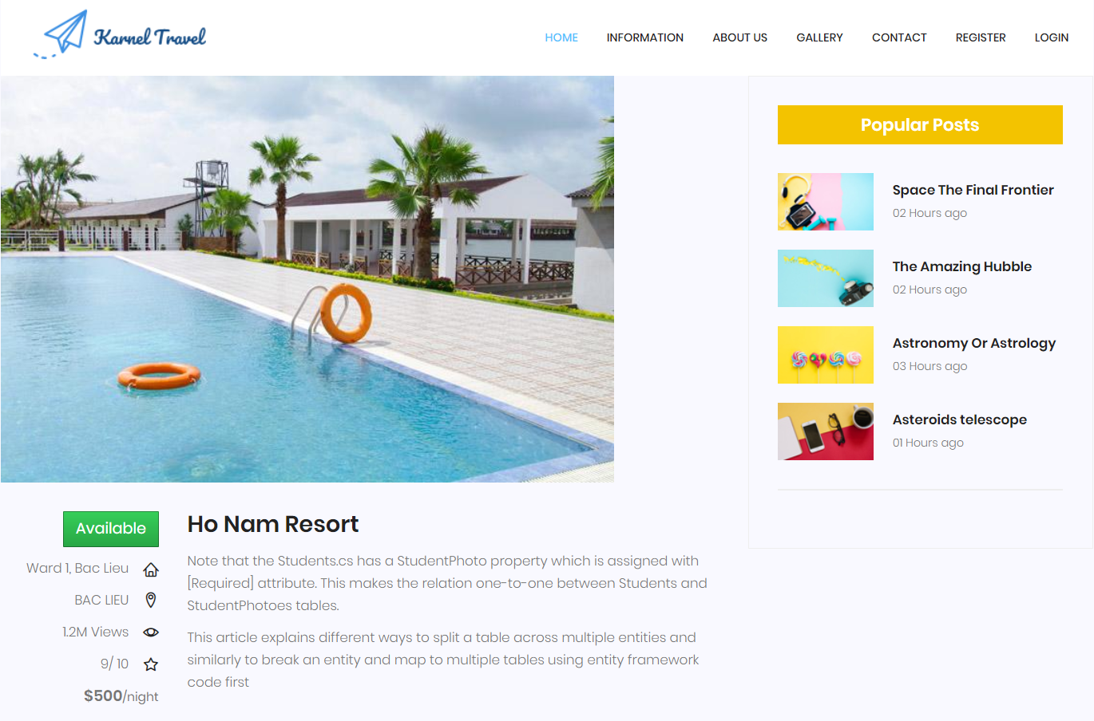

**O. Restaurant Information**

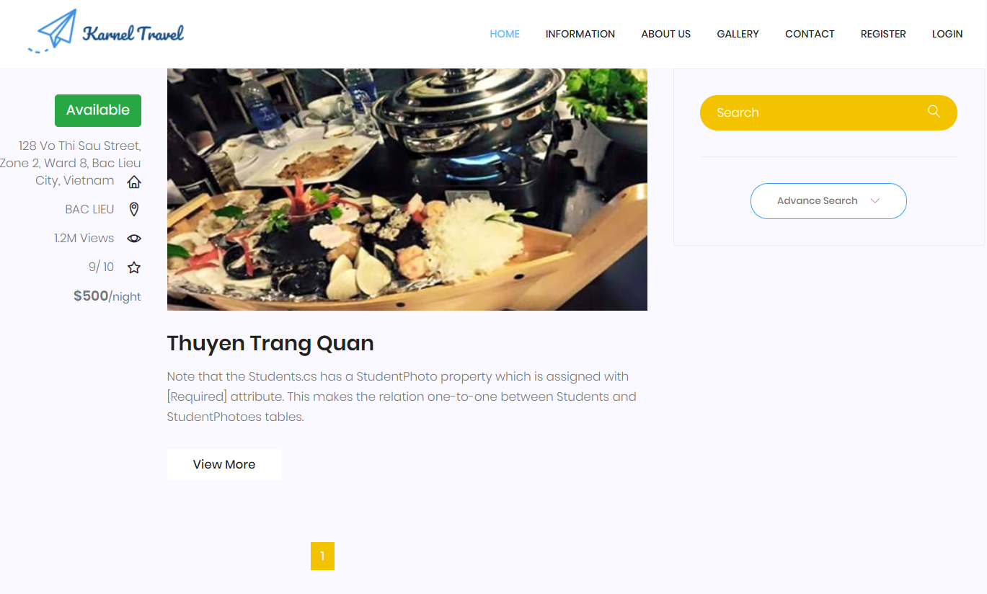

**P. Detail Restaurant**

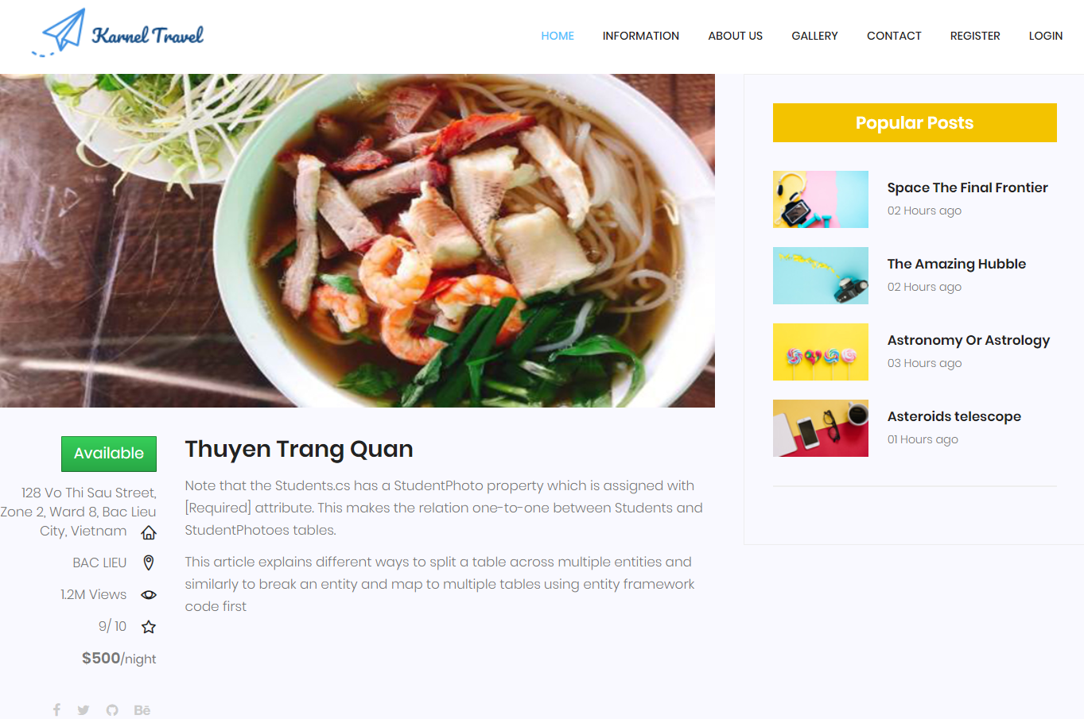

**Q. Travel Information**

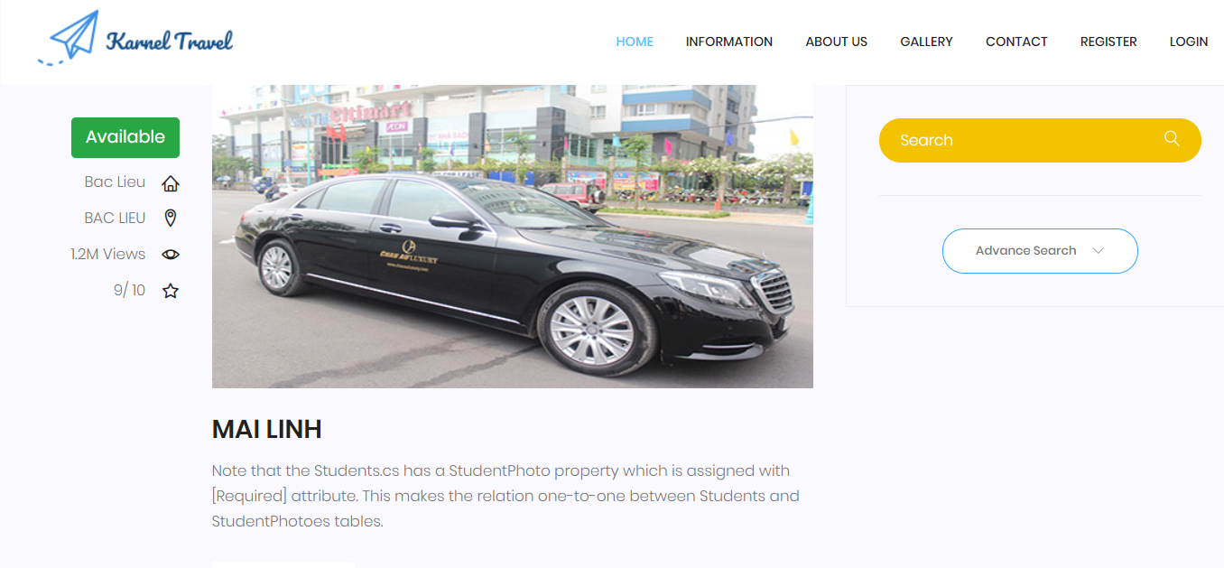

**R. Travel Information**

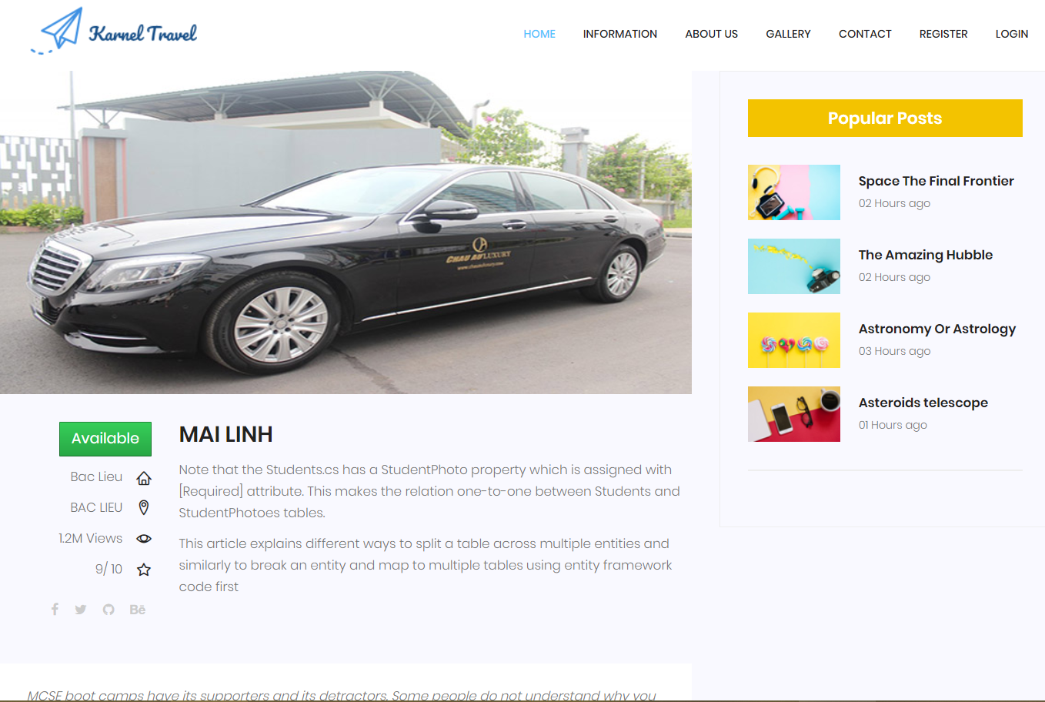

**S. Search Information:**

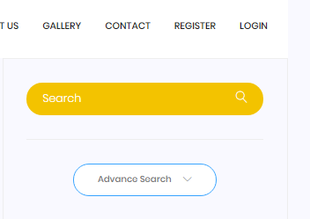

**T. Advance Search**:

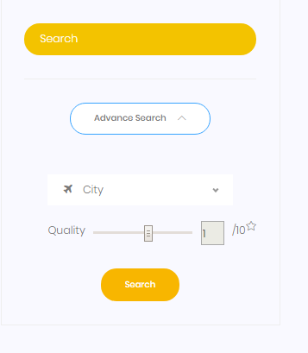

**Advance Search for Tourist Spot**

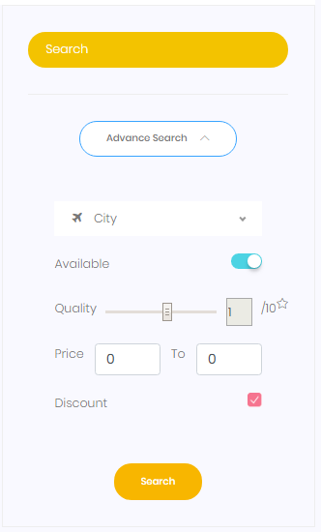

**Advance Search for Hotel/Travel/Resort/Restaurant**

|  |  |
| --- | --- |
| **Fields** | **Validation** |
| **Price** | **Min Price < Max Price** |

## Task Sheet Review 3

|  |  |  |  |  |  |
| --- | --- | --- | --- | --- | --- |
| **Members Group** | | **Date Preparation of Activity Plan** | | | |
| **No** | **Name** | **Description Task** | **Start Date** | **End Date** | **Status** |
| 1 | Ho Hoan Vu | ERD, GUI Main Page, View Page (Hotel, Tourist Spots), Search, Advance search. | **Oct 16, 2018** | **Oct 23, 2018** | Completed |
| 2 | Doan Khanh Nhi | ERD, GUI Main Page, View Page (Resort, Travel, Restaurant), | **Oct 16, 2018** | **Oct 23, 2018** | Completed |
| 3 | Vu Ngoc Truong | Admin GUI | **Oct 16, 2018** | **Oct 23, 2018** | Completed |
|  | | | | | |
| **Teacher** | | | **Team Leader** | | |
|  | | |  | | |
| **Dinh Vu Quoc Trung** | | | **Ho Hoan Vu** | | |